Julia A. Glendenning

Associate; Assistant Director

Forensic Department

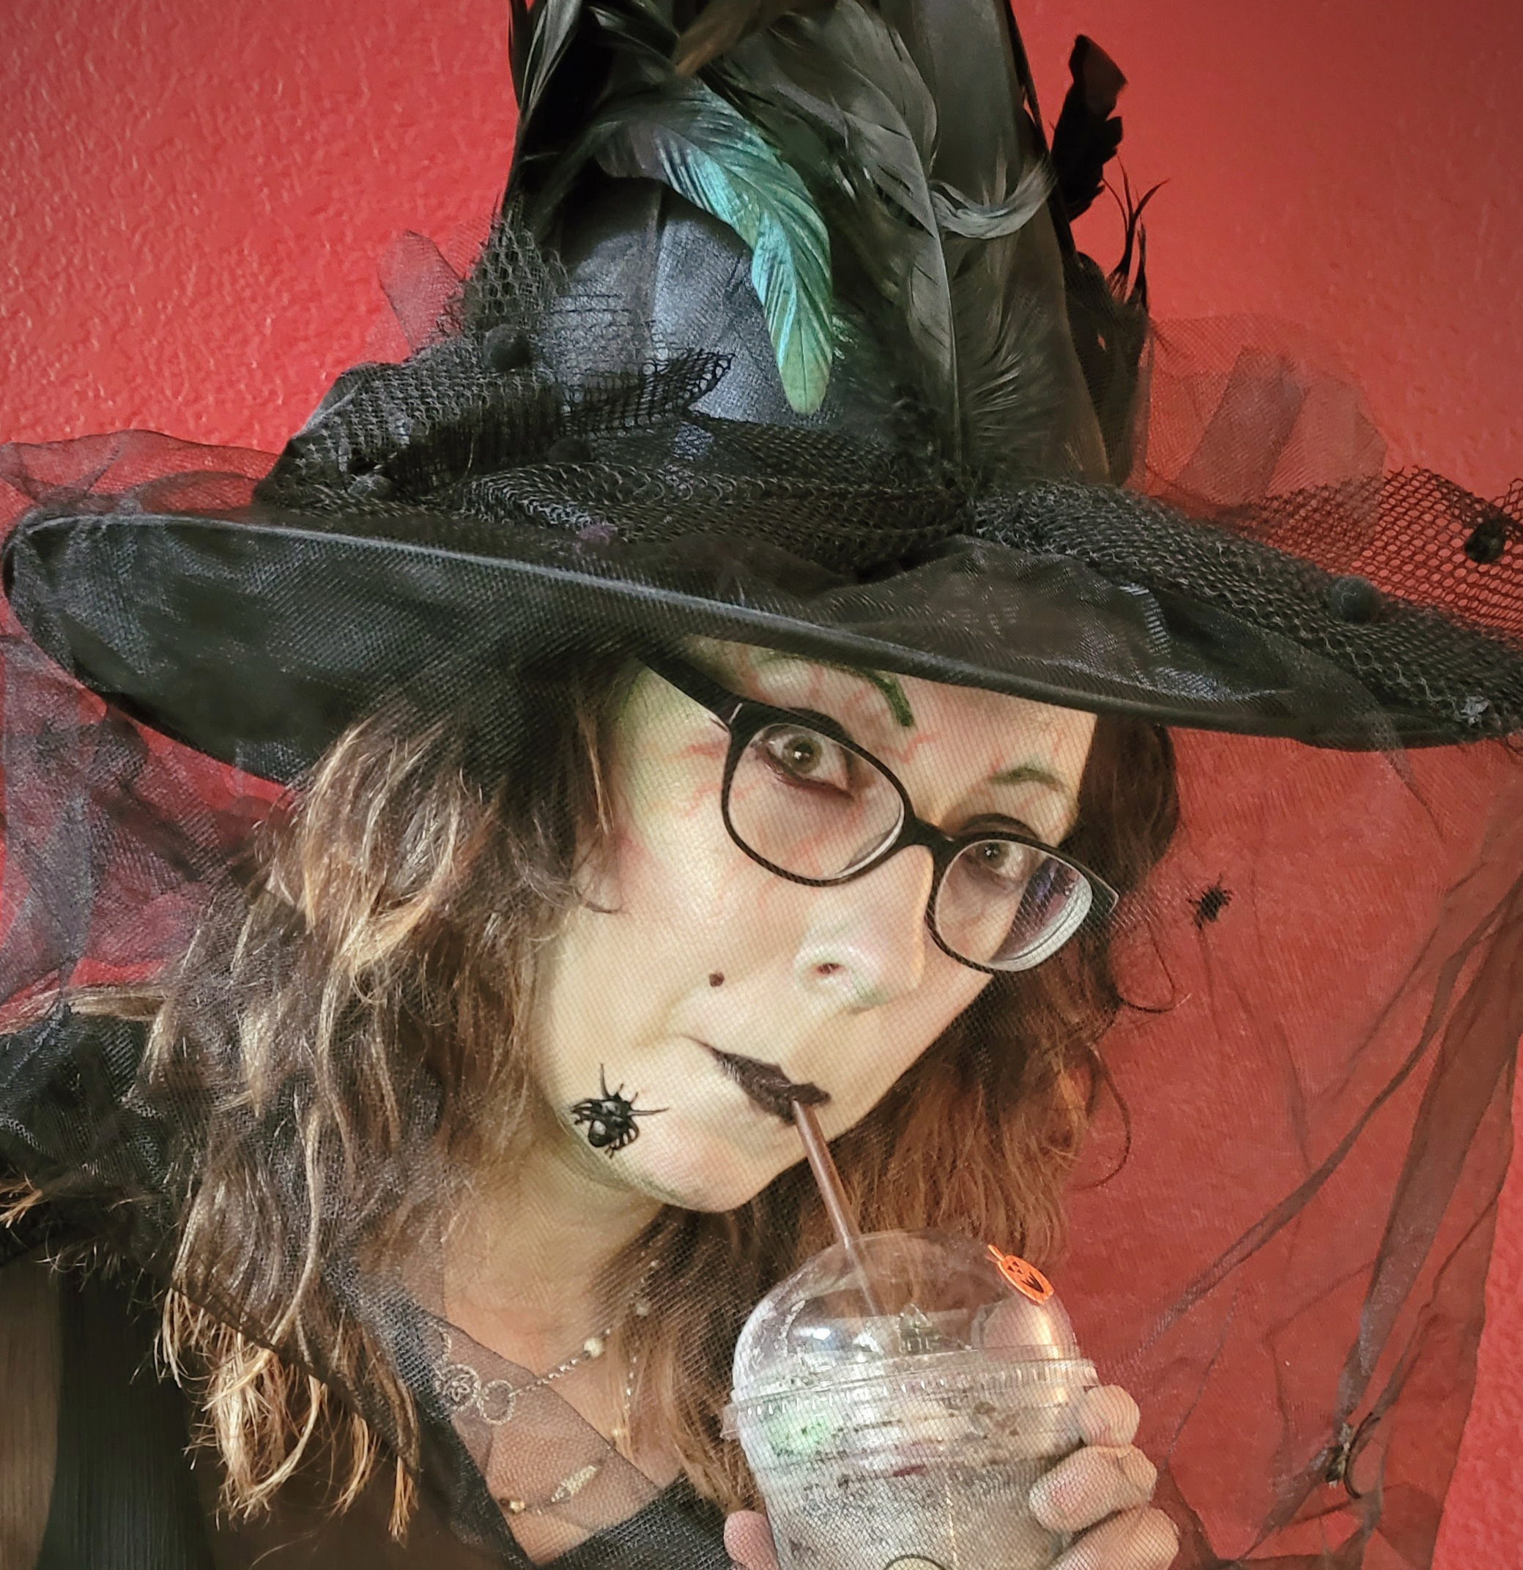 | Ms. Glendenning has been practicing as a Structural Engineering Technician within the industry since 2001. Her experiences include structural and forensic inspections, preparation of structural plans and details for various projects such as commercial, custom and standard swimming pool designs, specialty, and high end custom residential homes. Ms. Glendenning has been an ICC Certified Special Structural Inspector since 2008. She has experience and knowledge of building structures of steel, concrete, masonry, and timber building materials.  Ms. Glendenning’s experience also includes expert witness and litigation support services since 2010. Services include reviewing litigation documents, performing forensic evaluations, performing destructive testing and visual inspections, preparing comprehensive Excel spreadsheets with pertinent project information, and assisting in legal services with file organization skills, arbitration support, and preparation of exemplar exhibits.  PROFESSIONAL EXPERIENCE:  EDUCATION  PROFESSIONAL  QUALIFICATIONS  ICC – Structural Masonry Special Inspector – ICC # 5316589-84  ORGANIZATIONS  International Code Council (ICC) Member  American Concrete Institute
  2007 – Present | Starling Madison Lofquist, Inc., Phoenix, Arizona  Associate, Structural Engineering Forensic Department
  2005 – 2007 | Starling & Associates, INC., Phoenix, AZ  Structural Drafter, Drafting Department Manager
  2001 – 2005 | Rader-Gracia Engineering, L.L.C., Phoenix, Arizona  Drafting Manager and Office Manager
  1997 – 2001 and  2008 – 2015 | General Studies, Math, and Science  Mesa Community College, Mesa, AZ
  1992 – 1997 | High School Diploma  Mesa High School, Mesa, AZ

